WhiteBooks ASP Documentation
WhiteBooks providing 3 types of API’s. In this document we will learn about how to integrate WhiteBooks GST API’s and how to use these GST API’s.

How to Sign up and Integrate GST API’s in WhiteBooks:
STEP 1: Login into Account: Sign up as asp in WhiteBooks. After Login into WhiteBooks user will see the message to call the customer support.
STEP 2: Enable Account - Call The customer support ask them to enable the account. After Enabling the account, you will able to see all the dashboards and nav links.
STEP 3: Create Credentials – Click on credentials and click on create credential button in the bottom.
Provide all the required data in the pop up and then click on create. After that, call customer support ask to enable the sandbox Account.
STEP 4: Integration –
Use Base URL as: https://api.whitebooks.in
For exact url make any API call.
curl -X GET --header 'Accept: application/json' --header 'gst_username: val ' --header 'state_cd: val' --header 'ip_address: val' --header 'client_id: val ' --header 'client_secret: val ' 'https://api.whitebooks.in/authentication/otprequest?email=val%40gmail.com'

Replace val with respective values.

Process of using API’s:
The parameters in the API calls are
- email – Use the email id that you registered with WhiteBooks.
- gst_username – Gst.gov.in User Name of your client
- state_cd – Provide the State Code ( First 2 digits of your customer GSTIN )
- Fy - Financial Year (YYYY-YY)
- ip_address – Ip Address of the system you are using.
- client_id – Provide the client id that have given to you in the credentials tab table.
- client_secret - Provide the client Secret that have given to you in the credentials tab
- ret_period – return period it should be in MMYYYY format
- gstin- gst number of the customer
- txn – transaction numer which you will receive in Authentication call
- refid – reference ID
- ek - Encryption key from file details response
- Athentication/otprequest
The First step to use any API is to do Authentication OTP Request.
After Providing all the parameters click on Try It Out. In the response you will get TXN & and OTP will be sent to registered email and mobile number of your Client from GST Portal.
- Athentication/authtoken
Next go to AUTH token API to get authentication
Give all the details in the input filed as given above. Give OTP and TXN, that you got in the OTP request call response.
- /authentication/refreshtoken
The TXN number which we have got us valid for 6 hours. Before expiring the token, we need to make refresh token call.Every 6 hours you have to make this call to sustain the Token,

/authentication/logout
This is used to Logout from the API’s.
- /gstr1/retsave (Save GSTR1 data)
How to save the data in GSTR1, GSTR1A, GSTR2, and GSTRA… etc. For Reference here we are saving GSTR1.
In this call we will send all the details explained above with body. In This body user will give the data in the JSON format. We have given the Example body right side. As shown in the below image.
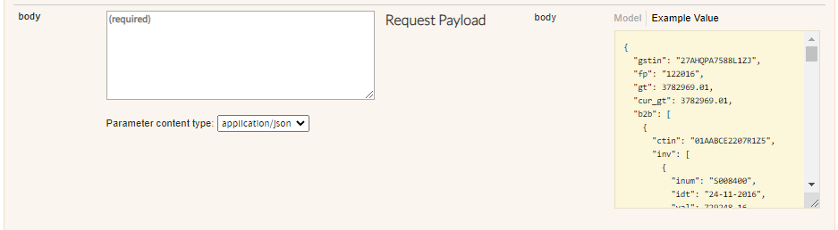
By using this call user will be able to save the data into GSTIN System. In the response you will get the refId. It will be useful to check the status of the saved data.

/gstr/retstatus
After Saving the data in any return type. User can check if the data is Accepted, rejected or in processing stage by Using this call. You need to provide the RefId that have been given to you in the response of retsave API call.
- /gstr1/b2b , /gstr1/exp , /gstr1/b2cs
User can see the data that has been provided to GSTIN by using the get calls from the API’s.
- /gstr1/retsubmit
This call is to submit the data into GSTIN submit. Before filing user has to submit the data.
- /gstr1/retfile
This step is to file the submitted data using digital Signature. Before filing user has to submit the data.
- /gstr1/retevcfile
This is another type of filing. In this step user will file the submitted data by using evc format.
- /gstr1/reset:
This is to reset the data if data is wrong or rejected. By using this call user can reset the data.
Above process is same for all the APIs to save and submit, file and get the data.

ALL API’s:
- /all/filedet:
This call is used to Get the File Details.
- /all/largefile:
This API is called for the large file URL to upload the data. to upload large file, we need to raise a request through this API. In the response user will give a link, it will activate in two hrs.
- /all/latefee:
This API is called to get details of late fee levied in GSTR3B and GSTR4. If it is Successful, gets the status of the Late Fee.

/all/docdwld:
This API is called for document download. If Successful, gets the status of the Document Download.
- /all/proceedfile:
This API is called for proceed to file. If Successful, gets the status of the Proceed to File.
- /all/savepref:
This API is called to Save Preference. To save which filing type user will use for the given financial year.

/all/getpref:
This API is called to get the Preference. To get which filing type user using for the given financial Year.

Public API’s:

/public/search :
This API is used to get taxpayer details.

/public/rettrack
This API used to view and Track Returns. In this call user don’t need the TXN value.

/public/pref
This call is used to know which filing type they are using for the given financial Year.

